Sign Up for Patent Drafter

Sign Up for Maker

Employee ID:

Employee ID:

Name:

Name:

Type of Drafter:

College:

Non – Chemical or

Chemical

Username:

Username:

Password:

Password:

Log in Director

Username:

Password:

Upload Certificate

View Notification of Publication

View Notice of Withdrawal Application

Upload Formality Exam Result

View Response

View Acknowledgement Receipt From IPOPHIL

View Submission Status

View Formality Exam Result

Submit Documents

Dashboard

UM Application

Patent

Registered UM

Documents Management System for SLSU KKTO

MAKER

In submitting a document, the maker should input;

Document Title:

Proponent:

Non – Chemical or

Chemical

Type of Technology:

Attached File

Contact Information:

Submitted Drafted Documents

View Submission

Upload Acknowledgement Receipt From IPOPHIL

Log Submission Status

Upload Formality Exam Result

Upload Notice of Withdrawal Application

Upload Response

Upload Notification of Publication

Upload Certificate

Dashboard

Registered UM

Patent

UM Application

Documents Management System for SLSU KKTO

Patent Drafter

In submitting a drafted document, the patent drafter should input;

Document Title:

Attached File

In Log Submission the Patent Drafter can be able to Edit.

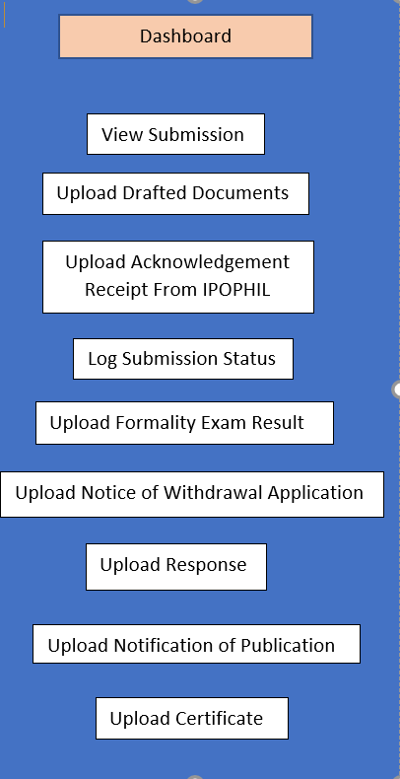

  

In Log Submission the Director can be able to Edit.

Documents Management System for SLSU KKTO

Director/Admin